Exercise 14
- Our Ceo fall in love with the petite Web Developer, Anamika Pandit. She now wants her last name to be changed to ‘Sharma’.
UPDATE employee_data set l_name="Sharma" where f_name="Anamika" and l_name="Pandit";
SELECT * FROM employee_data;
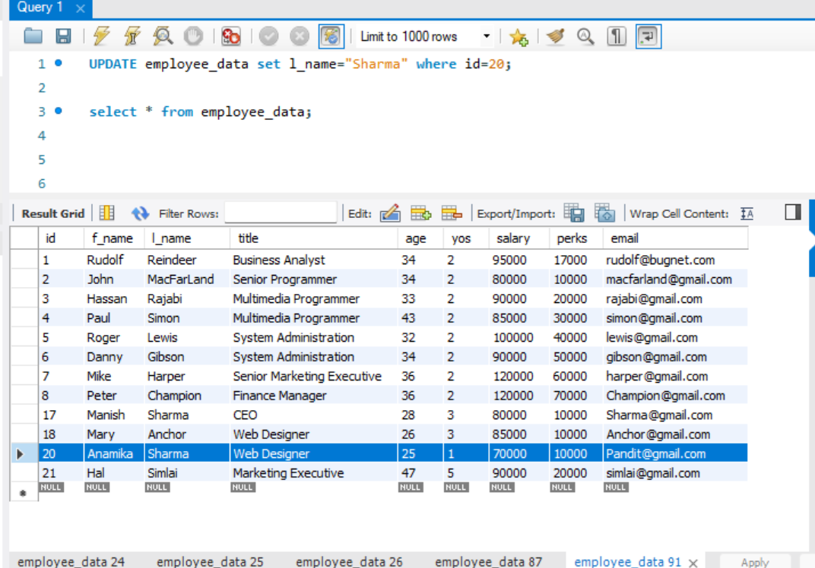
- All Multimedia Programmers now want to be called Multimedia Specialists.
UPDATE employee_data set title="Multimedia Specialist" where title="Multimedia Programmer";
SELECT * FROM employee_data;

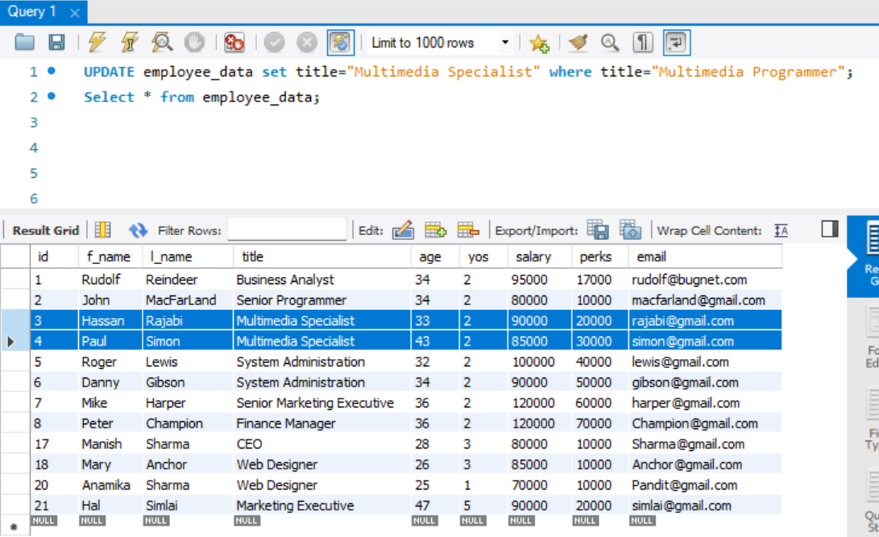
- After his marriage, the CEO gives everyone a raise. Increase the salaries of all employees (except the CEO) by $10000.
UPDATE employee_data set salary=salary + 10000 where title NOT LIKE "CEO";
SELECT * FROM employee_data;
